 

* Grafana: open-source visualization
* Prometheus: open-source event monitoring and alerting
* Prometheus exporters: exporting existing metrics from third-party systems as Prometheus metrics. ( <https://prometheus.io/docs/instrumenting/exporters/> )
  + Databases: MSSQL, MySQL, Redis etc.
  + Hardware: NVIDIA GPU exporter etc.
  + Issue trackers and continuous integration: Jenkins, Jira etc.
  + Messaging systems: Kafka, RabbitMQ etc.
  + Storage
  + HTTP
  + APIs: Docker Hub, Azure, AWS etc.

Example: RabbitMQ -> rabbitmq_exporter -> Prometheus -> Grafana

* Prometheus web panel: <http://localhost:9090/>
* Grafana web panel: <http://localhost:3000/>
* RabbitMQ web panel: <http://localhost:15672/>

RabbitMQ producer, consumer: 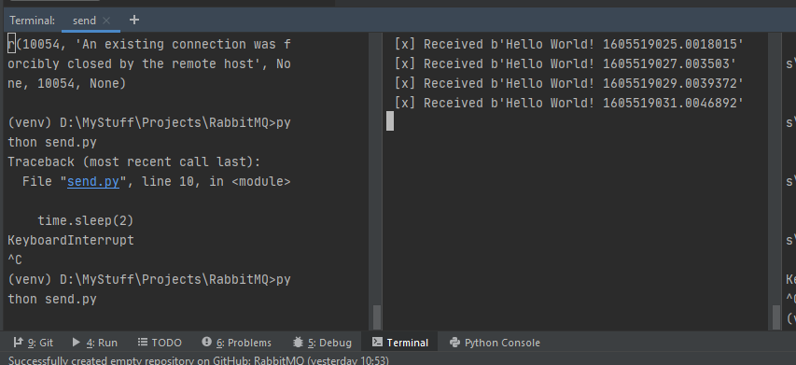

RabbitMQ web: 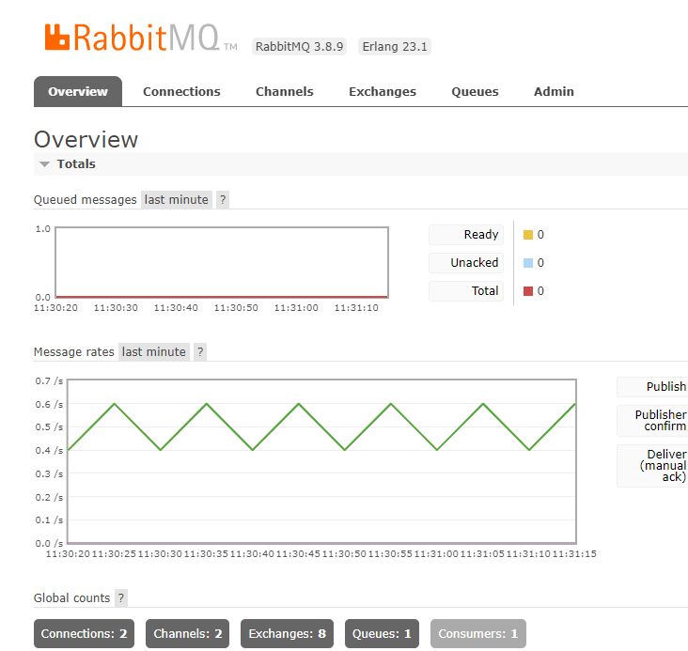

rabbitmq_exporter: 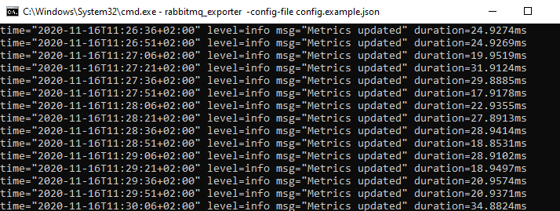

Grafana web: 